Dartmoor Forest Parish Council
Parish Clerk: Mr N K Tigwell,
Wheal Lucky House, Rundlestone, Princetown, Yelverton, Devon PL20 6SS
Telephone: 01822 890274, 07985 459 804
Email: clerk@dartmoorforestpc.net Website: www.dartmoorforestpc.net

INVITATION TO TENDER FOR POSTBRIDGE CEMETERY IMPROVEMENTS

Some years ago Dartmoor Forest Parish Council purchased an additional plot of land to extend Postbridge cemetery but the two areas remain divided by a small Devon hedge. The Council now wished to open an access between the two areas and is seeking tenders for the work.

The requirement is to open an access way between the two areas with a minimum width of eight feet or 2.5 metres between two of the mature beech trees slightly to the left of the line of the central path in the cemetery. The new access way is to be levelled to allow unimpeded access by pedestrians, ‘ride-on’ lawnmowers and ‘mini-diggers’; and sown with grass seed. No mature trees or tree roots are to be disturbed. The cut bank is to be tidied but there is no requirement to install gateposts. Stone is not to be removed from site.

Please address any questions or points of clarification to the Parish Clerk.

If you wish to be considered for this work please forward a quotation to the Parish Clerk by Friday 6 March 2015. Tender selection will take place by Monday 9 March.

Yours sincerely

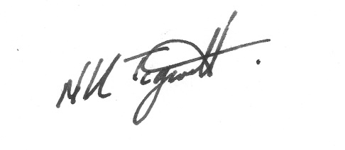

Nigel Tigwell
Parish Clerk

